7. Frank Gehry
7.1 Personal life
7.2 Architectural style
7.2.1 Academia
7.2.3 Celebrity status
7.2.4 Fish and furniture
7.3 Works
7.3.1 Awards
8 Ben van Berkel
8.1 Personal awards and affiliations
8.2 Selected projects
8.2.1 Current Projects
8.2.2 Past projects
9 Zvi Hecker
9.1 Architectural career
9.2 Projects

7. Frank Gehry

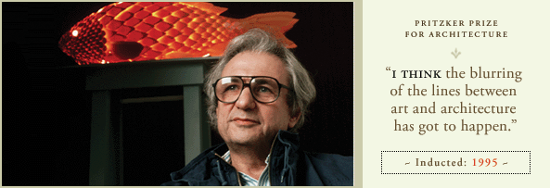

Frank Owen Gehry, CC (born Frank Owen Goldberg; February 28, 1929) is a Canadian-American Pritzker Prize-winning architect based in Los Angeles.

His buildings, including his private residence, have become tourist attractions. His works are cited as being among the most important works of contemporary architecture in the 2010 World Architecture Survey, which led Vanity Fair to label him as "the most important architect of our age".

Gehry's best-known works include the titanium-covered Guggenheim Museum in Bilbao, Spain; MIT Ray and Maria Stata Center in Cambridge, Massachusetts; Walt Disney Concert Hall in downtown Los Angeles; Experience Music Project in Seattle; Weisman Art Museum in Minneapolis; Dancing House in Prague; the Vitra Design Museum and MARTa Museum in Germany; the Art Gallery of Ontario in Toronto; the Cinémathèque française in Paris; and 8 Spruce Street in New York City. But it was his private residence in Santa Monica, California, which jump-started his career, lifting it from the status of "paper architecture"—a phenomenon that many famous architects have experienced in their formative decades through experimentation almost exclusively on paper before receiving their first major commission in later years. Gehry is also the designer of the future Dwight D. Eisenhower Memorial. Contents
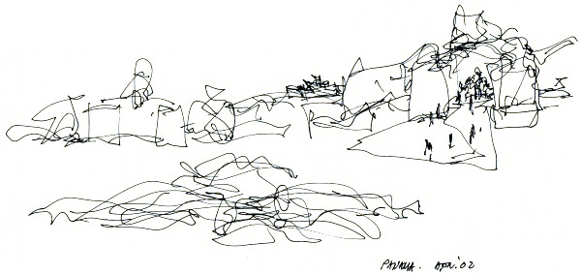

7.1 Personal life

Gehry was born Frank Owen Goldberg on February 28, 1929, in Toronto, Ontario to parents, Irwin and Thelma (née Thelma Caplan) Goldberg. His parents were Polish Jews. A creative child, he was encouraged by his grandmother, Mrs. Caplan, with whom he would build little cities out of scraps of wood. With these scraps from her husband's hardware store, she entertained him for hours, building imaginary houses and futuristic cities on the living room floor. His use of corrugated steel, chain link fencing, unpainted plywood and other utilitarian or "everyday" materials was partly inspired by spending Saturday mornings at his grandfather's hardware store. He would spend time drawing with his father and his mother introduced him to the world of art. "So the creative genes were there", Gehry says. "But my father thought I was a dreamer, I wasn't gonna amount to anything. It was my mother who thought I was just reticent to do things. She would push me."

He was given the Hebrew name "Ephraim" by his grandfather but only used it at his bar mitzvah.

In 1947 Gehry moved to California, got a job driving a delivery truck, and studied at Los Angeles City College, eventually to graduate from the University of Southern California's School of Architecture. According to Gehry: “I was a truck driver in L.A., going to City College, and I tried radio announcing, which I wasn't very good at. I tried chemical engineering, which I wasn't very good at and didn't like, and then I remembered. You know, somehow I just started racking my brain about, "What do I like?" Where was I? What made me excited? And I remembered art, that I loved going to museums and I loved looking at paintings, loved listening to music. Those things came from my mother, who took me to concerts and museums. I remembered Grandma and the blocks, and just on a hunch, I tried some architecture classes.” In 1952 he married Anita Snyder, and in 1956 he changed his name to Frank O. Gehry at her suggestion, in part because of the anti-semitism he had experienced as a child and as a undergraduate at USC. Gehry graduated at the top of his class with a Bachelor of Architecture degree from USC in 1954. Afterwards, he spent time away from the field of architecture in numerous other jobs, including service in the United States Army. In the fall of 1956, he moved his family to Cambridge, where he studied city planning at the Harvard Graduate School of Design. He left before completing the program, disheartened and underwhelmed. Gehry's left-wing ideas about socially responsible architecture were under-realized, and the final straw occurred when he sat in on a discussion of one professor's "secret project in progress" - a palace that he was designing for right-wing Cuban Dictator Fulgencio Batista (1901-1973). In 1966 he and Snyder divorced. In 1975 he married Panamanian Berta Isabel Aguilera, his current wife. He has two daughters from his first marriage, and two sons from his second marriage.

Having grown up in Canada, Gehry is a huge fan of ice hockey. He began a hockey league in his office, FOG (which stands for Frank Owen Gehry), though he no longer plays with them.[citation needed] In 2004, he designed the trophy for the World Cup of Hockey.[citation needed] Gehry holds dual citizenship in Canada and the United States. He lives in Santa Monica, California, and continues to practice out of Los Angeles.

7.2 Architectural style

Much of Gehry's work falls within the style of Deconstructivism, which is often referred to as post-structuralist in nature for its ability to go beyond current modalities of structural definition. In architecture, its application tends to depart from modernism in its inherent criticism of culturally inherited givens such as societal goals and functional necessity. Because of this, unlike early modernist structures, Deconstructivist structures are not required to reflect specific social or universal ideas, such as speed or universality of form, and they do not reflect a belief that form follows function. Gehry's own Santa Monica residence is a commonly cited example of deconstructivist architecture, as it was so drastically divorced from its original context, and in such a manner as to subvert its original spatial intention.

Gehry is sometimes associated with what is known as the "Los Angeles School" or the "Santa Monica School" of architecture. The appropriateness of this designation and the existence of such a school, however, remains controversial due to the lack of a unifying philosophy or theory. This designation stems from the Los Angeles area's producing a group of the most influential postmodern architects, including such notable Gehry contemporaries as Eric Owen Moss and Pritzker Prize-winner Thom Mayne of Morphosis, as well as the famous schools of architecture at the Southern California Institute of Architecture (co‑founded by Mayne), UCLA, and USC where Gehry is a member of the Board of Directors.

Gehry’s style at times seems unfinished or even crude, but his work is consistent with the California "funk" art movement in the 1960s and early 1970s, which featured the use of inexpensive found objects and non-traditional media such as clay to make serious art[citation needed]. Gehry has been called "the apostle of chain-link fencing and corrugated metal siding". However, a retrospective exhibit at New York's Whitney Museum in 1988 revealed that he is also a sophisticated classical artist, who knows European art history and contemporary sculpture and painting[citation needed].

Reception of Gehry's work is not always positive. Art historian Hal Foster reads Gehry's architecture as, primarily, in the service of corporate branding. Criticism of his work includes complaints that the buildings waste structural resources by creating functionless forms, do not seem to belong in their surroundings and are apparently designed without accounting for the local climate.

His proposed design for the national Dwight D. Eisenhower Memorial has been severely criticized by Susan Eisenhower, who said that her entire family opposes it.[12][13] Roger L. Lewis, an architect and a professor emeritus at the University of Maryland, criticized and opposed the design in the Washington Post: "Building a quasi-fenced precinct makes no sense. The narrative theme relating to Eisenhower’s boyhood, so visually dominant in the present design, also makes no sense. Gehry instead could craft a less grandiose yet visually powerful memorial composition..." Columnist Richard Cohen wrote that the Memorial does not accurately capture Eisenhower's life. George F. Will also opposed the design in the Washington Post. The design has been criticized in The New Republic, National Review, Foreign Policy, Metropolis Magazine, The American Spectator, and The Washington Examiner.

However, Philip Kennicott, the Washington Post's culture critic, praised the design: "Gehry has produced a design that inverts several of the sacred hierarchies of the classical memorial, emphasizing ideas of domesticity and interiority rather than masculine power and external display. He has 're-gendered' the vocabulary of memorialization, giving it new life and vitality..."

7.2.1 Academia

Gehry is a Distinguished Professor of Architecture at Columbia University and teaches advanced design studios at the Yale School of Architecture. He has received honorary doctoral degrees from Occidental College, Whittier College, the Southern California Institute of Architecture, the University of Toronto, the California College of Arts and Crafts, the Technical University of Nova Scotia, the Rhode Island School of Design, the California Institute of the Arts, and the Otis Art Institute at the Parsons School of Design. In 1982 and 1989, he held the Charlotte Davenport Professorship in Architecture at Yale University. In 1984, he held the Eliot Noyes Chair at Harvard University. In January 2011 he joined the University of Southern California (USC) faculty, as the Judge Widney Professor of Architecture.

7.2.2 Celebrity status

Gehry is considered a modern architectural icon and celebrity, a major "Starchitect" — a neologism describing the phenomenon of architects attaining a sort of celebrity status. Although Gehry has been a vocal opponent of the term, it usually refers to architects known for dramatic, influential designs that often achieve fame and notoriety through their spectacular effect. Other notable celebrity architects include Richard Meier, Jean Nouvel, Zaha Hadid, Thom Mayne, Steven Holl, Rem Koolhaas, and Norman Foster. Gehry came to the attention of the public in 1972 with his "Easy Edges" cardboard furniture. He has appeared in Apple's black-and-white "Think Different" pictorial ad campaign that associates offbeat but revered figures with Apple's design philosophy. He even once appeared as himself in The Simpsons in the episode "The Seven-Beer Snitch", where he parodied himself by intimating that his ideas are derived by looking at a crumpled paper ball. He also voiced himself on the TV show Arthur, where he helped Arthur and his friends design a new treehouse. Steve Sample, President of the University of Southern California, told Gehry that "...After George Lucas, you are our most prominent graduate". In 2009 Gehry designed a hat for pop star Lady Gaga, reportedly by using his iPhone.

7.2.3 Fish and furniture

Gehry is very much inspired by fish. Not only do they appear in his buildings, he created a line of jewelry, household items, and sculptures based on this motif. "It was by accident I got into the fish image", claimed Gehry. One thing that sparked his interest in fish was the fact that his colleagues are recreating Greek temples. He said, "Three hundred million years before man was fish....if you gotta go back, and you're insecure about going forward...go back three hundred million years ago. Why are you stopping at the Greeks? So I started drawing fish in my sketchbook, and then I started to realize that there was something in it."

Standing Glass Fish is just one of many works featuring fish which Gehry has created. The gigantic fish is made of glass plates and silicone, with the internal supporting structure of wood and steel clearly visible. It soars above a reflecting pool in a glass building built especially for it, in the Minneapolis Sculpture Garden. Another huge Gehry fish sculpture, built in 1992, is located in front of the Port Olímpic, in Barcelona, Spain, and another one dominates a public garden in front of the Fishdance Restaurant in Kobe, Japan.

In addition to architecture, Gehry has made a line of furniture, jewelry for Tiffany & Co., various household items, sculptures, and even a glass bottle for Wyborowa Vodka. His first line of furniture, produced from 1969 to 1973, was called "Easy Edges", constructed out of cardboard. Another line of furniture released in the spring of 1992 is "Bentwood Furniture". Each piece is named after a different hockey term. He was first introduced to making furniture in 1954 while serving in the U.S. Army, where he designed furniture for the enlisted soldiers. Gehry claims that making furniture is his "quick fix".

7.3 Works

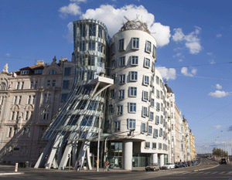
1989 Pritzker Prize
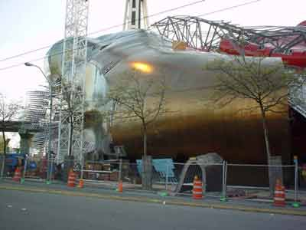

EXPERIENCE MUSIC PROJECT
Seattle, Washington

The Experience Music Project, located on 5th Avenue adjacent to the Space Needle at Seattle Center, is a 140,000 square foot facility intended to celebrate creativity and innovation as expressed through American popular music and culture. The Experience Music Project provides, in an educational museum and exhibition environment, opportunities for visitors to explore the history and traditions of American popular music, to participate in the music making process, to experience great music and to learn the secrets of its composition and its performance. The Experience Music Project places a special emphasis on music related traditions and music making in the Pacific Northwest and will specifically commemorate Jimi Hendrix, one of American music's most creative, innovative and influential artists.
The exhibits and public programs of the Experience Music Project are envisioned as a three-dimensional floating puzzle, with each piece being critical to the shape and the nature of the whole. Six elements, the Sky Church, the Crossroads, the Sound Lab, the Artist's Journey, the Electric Library, and the Ed. House form the basis of the Experience Music Project's exhibits and public programs. The Sky Church, a concept inspired by Jimi Hendrix, represents the coming together of all types of people united by the power and joy of music and music making and is physically embodied in the building's central public gathering area. The Crossroads, through a series of exhibition areas, presents the collision of multiple viewpoints and traditions, which is American popular music. The Sound Lab enhances the visitor's experience of music and music making by providing hands-on opportunities to create and illustrate some of the relationships between music, science, and technology. The Artist's Journey provides a compelling history of the life and times of popular music artists, illuminating the human aspect of their artistry and revealing the unexpected events and formative experiences that contributed to their creative development. The Electric Library provides a multimedia archive of the Experience Music Project's collection and information resources and provides services that are available both on site and on-line. The Ed. House, which will also function as an educational public outreach program, provides opportunities to learn more about the themes explored in the exhibit areas, to experience and participate in a variety of musical activities, and to further explore and develop creative abilities and music-related skills.
The building itself consists of a cluster of colorful curving elements clad in a variety of materials. The fragmented and undulating forms of the building are inspired in part by the image of a shattered Fender Stratocaster guitar. The Seattle Center Monorail, a remnant of the 1962 World's Fair that continues to provide transportation between Seattle Center and downtown Seattle, passes through the building, allowing Monorail riders to glimpse the inside. In addition to 35,000 square feet of exhibition space, the building houses a restaurant, a bookstore and administrative spaces, with support spaces and storage areas located beneath grade.

GUGGENHEIM MUSEUM NEW YORK
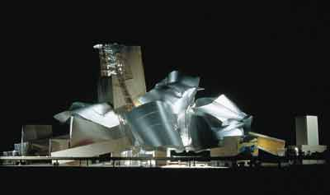

The site for the new Guggenheim Museum complex is located on the East River between Pier 14 to the North and Pier 9 to the South, adjacent to the South Street Seaport at the junction of Wall Street and FDR Drive.

In response to the dramatic nature of the waterfront site and the lower Manhattan skyline, the Guggenheim Museum complex is conceived as a building which would be elevated above the East River, at points rising from 64 feet to 112 feet above the surface of the River. The building would be supported by six reinforced super pylons that would be anchored directly into the bedrock of the riverbed. Raising the building above the surface of the River in this manner would allow a sense of openness to be maintained at street level, so that the visual corridor to the River would remain open from Wall Street and the surrounding neighborhood. A 279,000 square foot flat platform would be built beneath the Museum complex on the surface of the River at street level. This platform would function as a public plaza, accommodating a variety of public activities, as well as accommodating two vehicular drop off areas, art delivery facilities, and retail spaces for the Museum complex. The curvilinear outline of the public plaza would reinforce and enhance the uninterrupted flow of pedestrian traffic along the planned lower Manhattan waterfront esplanade between the South Street Seaport and the Wall Street heliport. A 41,000 square foot Water Garden, which would be converted into an ice skating rink during winter months, would be located in the center of the public plaza and would surround a 375 foot tall glass enclosed Central Atrium.
The Museum complex would be accessed through the Central Atrium, which would contain ticketing and Museum information facilities, as well as a cafŽ which would overlook the Water Garden and which would take full advantage of panoramic views of the River. From the Central Atrium, a number of grand escalators would lead visitors to a second atrium space located 64 feet above the surface of the River. Exhibition galleries, which would step up dramatically to maximum height of 256 feet above the surface of the River, would be accessed through this second atrium space. The Guggenheim Museum complex would include five components: the Permanent Collection, the Temporary Exhibition, the Center for Arts and Technologies, the Center for Architecture and Design, and a 450 foot tall Tower which would house various museum amenities, as well as executive suites and a gourmet restaurant on its uppermost levels.
Two courtyards created in the void spaces within the North and South wings of the Museum complex would allow natural light to filter down to the Water Garden and the public plaza. The sculptural underside of the Museum complex would act as a ceiling sheltering the public plaza, suggesting to visitors the experience of being within a unique urban room open to the River. An 1100 seat performing arts center would be included in the Guggenheim Museum complex. The performing arts center would be located just to the North of the Museum complex and would be accessible directly from the pedestrian esplanade along the River. In addition, a proposed new ferry terminal would replace one of the piers currently existing on the site of the Museum complex. Rising dramatically above the surface of the East River, the proposed Guggenheim Museum complex would transform its lower Manhattan site into a highly unique cultural destination.

7.3.1 Awards
1989 - Pritzker Architecture Prize
1994 - The Dorothy and Lillian Gish Prize
1995 - Academy of Achievement's Golden Plate Award
1998 - National Medal of Arts[30]
1999 - AIA Gold Medal
2000 - Cooper–Hewitt, National Design Museum Lifetime Achievement Award[31]
2003 - Order of Canada[32]
2004 - Woodrow Wilson Award for Public Service
2006 - Inductee, California Hall of Fame
2007 - Henry C. Turner Prize for Innovation in Construction Technology (on behalf of Gehry Partners and Gehry Technologies)
2008 - Order of Charlemagne (declined honor)[citation needed]

Gehry was elected to the College of Fellows of the American Institute of Architects (AIA) in 1974, and he has received many national, regional and local AIA awards. He is a Senior Fellow of the Design Futures Council and serves on the steering committee of the Aga Khan Award for Architecture.

8 Ben van Berkel
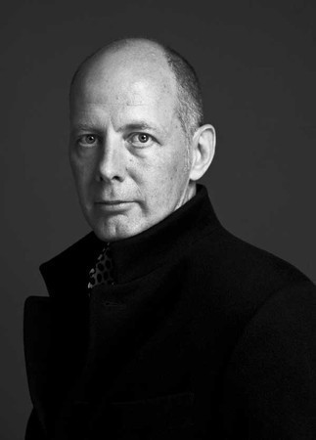
Ben van Berkel (born 1957) is a Dutch architect. He studied architecture at the Rietveld Academy in Amsterdam, and at the Architectural Association in London, receiving the AA Diploma with Honours in 1987.

In 1988 he and Caroline Bos set up an architectural practice in Amsterdam named Van Berkel & Bos Architectuurbureau, which realized, amongst others projects, the Karbouw office building, the Erasmus Bridge in Rotterdam, Museum Het Valkhof in Nijmegen, the Moebius house, and the NMR facilities for the University of Utrecht.

In 1998 van Berkel and Bos relaunched their practice as UNStudio, the UN standing for "United Net". UNStudio presents itself as a network of specialists in architecture, urban development and infrastructure. With UNStudio, van Berkel has built several projects, including the Mercedes-Benz Museum in Stuttgart, a façade and interior renovation for the Galleria Department store in Seoul, Korea, and a private villa in up-state New York. Current projects are the restructuring of the station area of Arnhem, a masterplan for Basauri, Spain, the Dance Palace in Saint Petersburg, Russia and the design and restructuring of the Harbor Ponte Parodi in Genoa. In 2009 New Amsterdam Pavilion in Battery Park in Manhattan was revealed. The pavilion was presented to the city of New York by the Dutch government to celebrate 400 years of relations between New York and the Netherlands.

Ben van Berkel has lectured and taught at many architectural schools around the world. He has led Diploma Units at the Berlage Institute in Rotterdam (1992-1993) and the Architectural Association in London (1999). Before he became Professor Conceptual Design at the Städelschule in Frankfurt in 2001, he was Visiting Professor at Columbia University, Princeton University and Harvard University. In 2011 Ben van Berkel was appointed the Kenzo Tange Chair at the Harvard Graduate School of Design. Central to his teaching is the inclusive approach of architectural works integrating virtual and material organisation and engineering constructions.

8.1 Personal awards and affiliations

Member of advisory board for Gehry Technologies (2011)
RIBA International Fellowship (2009)
Charles Jencks Award (2007)
1822-Kunstpreis 2003 (Mercedes-Benz Museum, Stuttgart) (2003)
Member of Honor of the Bund Deutsche Architekten (1997)
Charlotte Köhler Award (1991)
British Council Fellowship (1986)
Eileen Gray Award (1983)

8.2 Selected projects
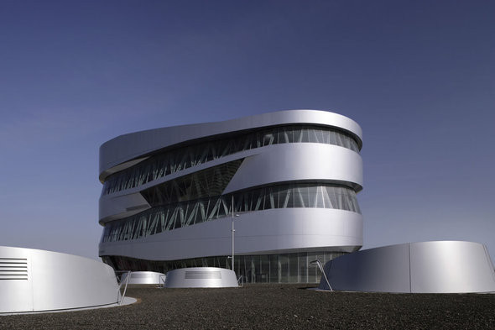  MERSEDES-BENZ MUSEUM | 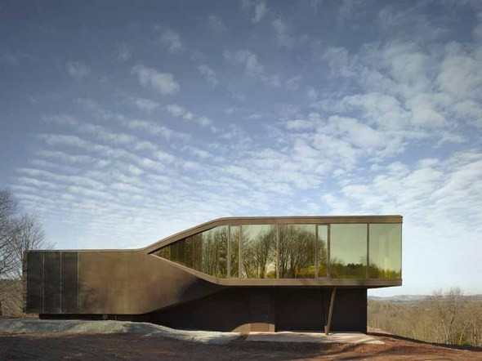  VILA NM
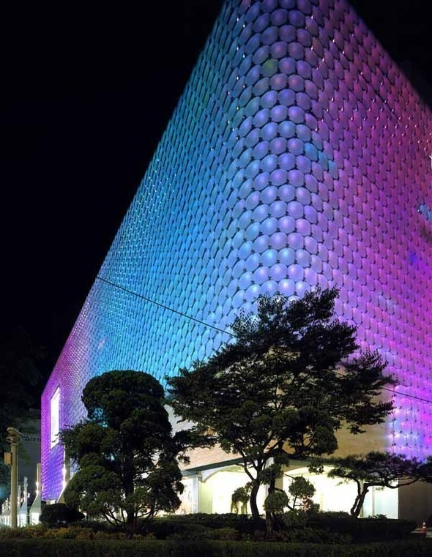  GALLERIA DEPARTMENT STORE | 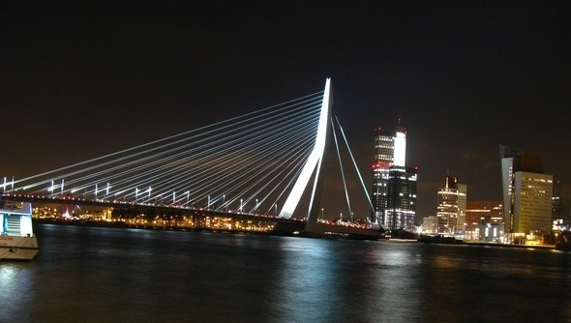  THE ERASMUS BRIDGE
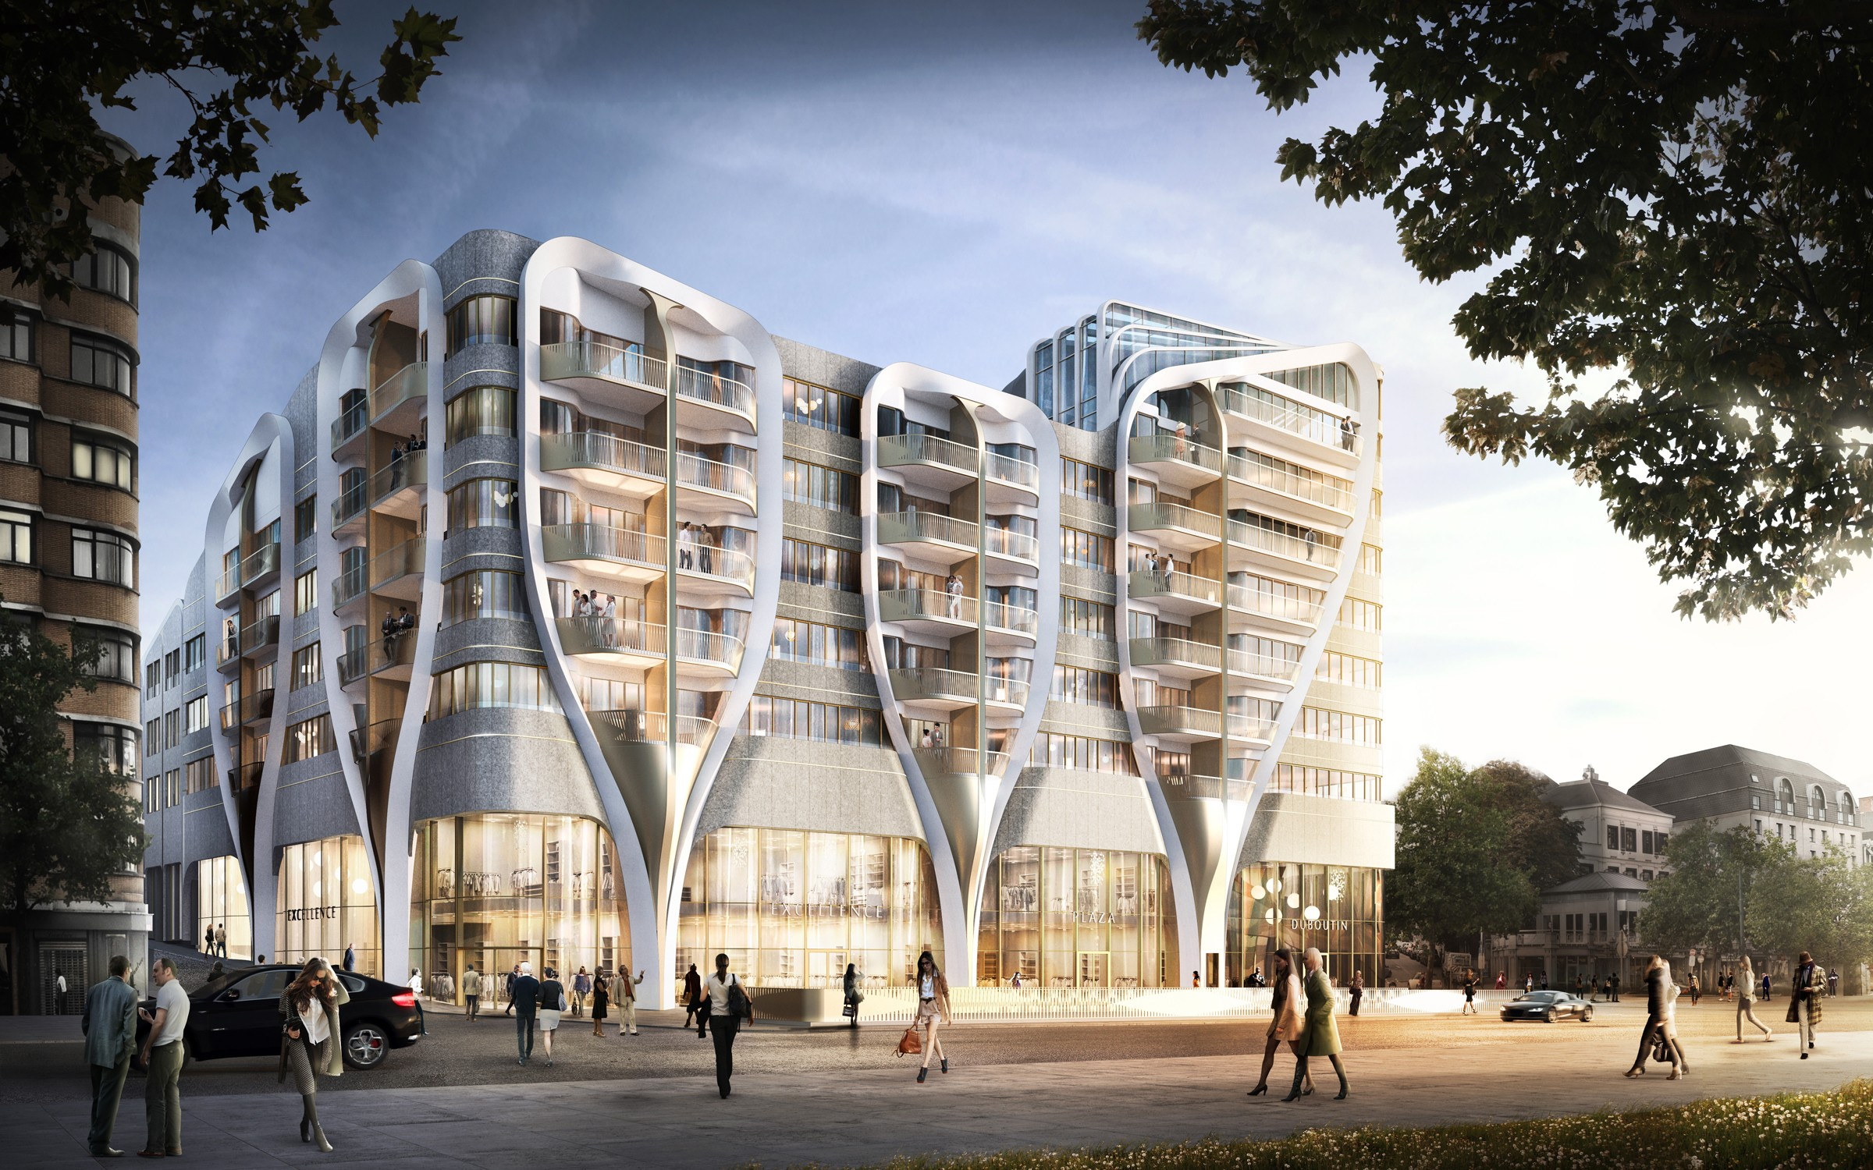

The mixed-use retail and residential complex is located on the Avenue de la Toison d'Or, between the two historical gates, the Porte Louise and the Port de Namur. Essential to the design is the urban context and the connection to the existing buildings. In addition, the programme and the sustainable aspects of the project form decisive elements. The strong verticality of the existing facade rhythm was continued in the design for the Toison d'Or building. The duality of the programme (retail and apartments) is translated into the façade design by means of V-shaped portals which act as a visual link between the two functions. These portals further create diversity and rhythm in the facade, in addition to emphasising the terrace spaces of the upper apartments. Le Toison d'Or contains varied sized apartments, 13,000 m2 of commercial space and 400 parking spaces.
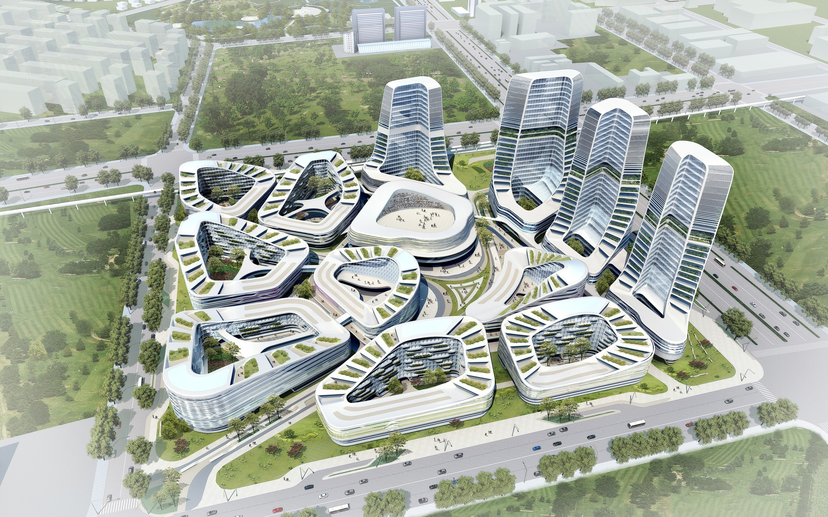
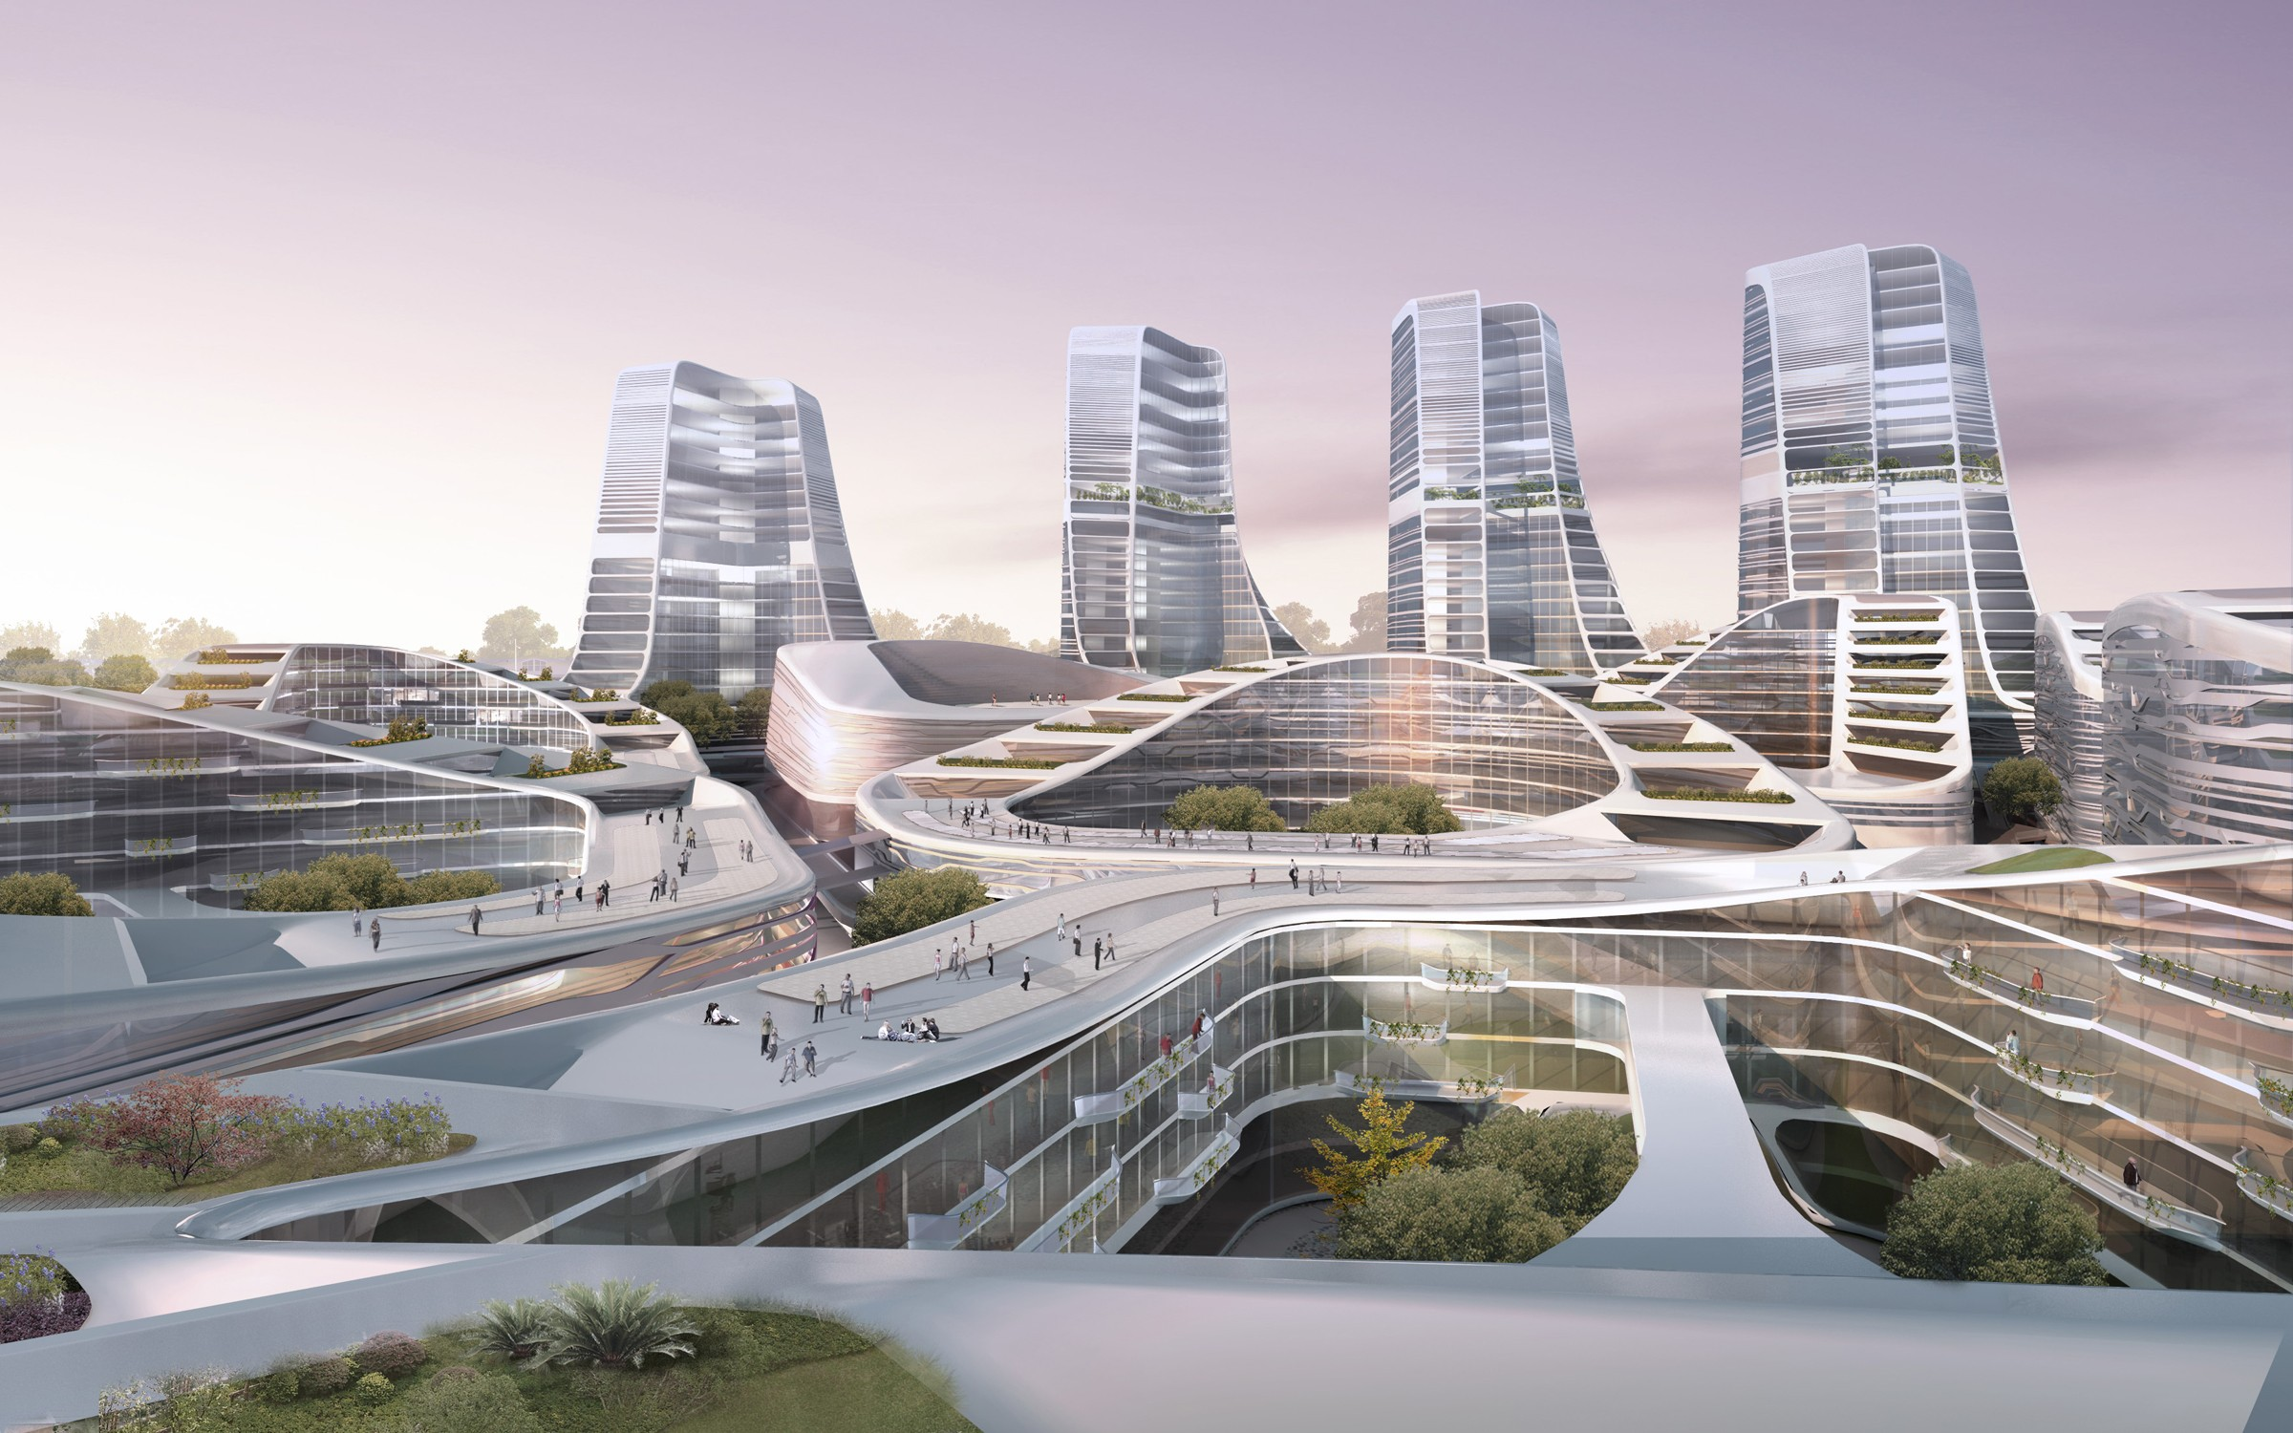

International Investment Square
Beijing, China, 2009

The buildings in the master plan for the International Investement Square in Beijing fall into two distinct categories, low rise buildings and towers. The urban organisation utilizes a consistent distribution of buildings in rings of various shapes and sizes, with each building encircling an internal courtyard. The building programme is distributed over three distinct yet interrelated neighbourhoods. Each of these is subdivided again in order to generate a new level of privacy and individuality. A third level is introduced by the semi-public courtyards at the core of the enclosed building blocks. The shapes of the roofs are articulated so as to achieve a harmonious and coherent master plan, as well as ensuring good sun orientation and excellent views for the apartments.

8.2.1 Current Projects

Beijing New Scitech Reconstruction (2011), Mixed-use, Beijing, China
Shenton Way (2010), Mixed-use, Singapore
Singapore University of Technology and Design (2010), Singapore
Scotts Road (2010), Residential Tower, Singapore
Entre Les Deux Portes (2010), Commercial and Residential Complex, Brussels, Belgium
Twofour54 (2009), Media Campus, Abu Dhabi, United Arab Emirates
Dance Palace (2009), Saint Petersburg, Russia
Raffles City (2008), Mixed-use, Hangzhou, China
Post Rotterdam (2007), Lifestyle Retail Centre and Hotel, Rotterdam, The Netherlands
Arnhem Central Station (1996), Arnhem, The Netherlands
Ponte Parodi (2000), Harbor Redevelopment, Genoa, Italy

8.2.2 Past projects

Exhibition Motion Matters (2011), Harvard University Graduate School of Design, Cambridge, United States of America
New Amsterdam Chair (2011-2011), Wilde + Spieth
Youturn Pavilion (2010), Sao Paulo Art Biennale, Sao Paulo, Brasil
SitTable (2010), PROOFF
Diakonessenhuis Health Care Campus (2009), Utrecht, The Netherlands
Creative Zone Masterplan (2009), Beijing, China
Twofour54 Media Center (2009), Abu Dhabi, United Arab Emirates
Galleria Cheonan Department Store (2008-2010), Cheonan, South-Korea
Lock Island Bridges (2008), Dubai, United Arab Emirates
Mychair (2008), Walter Knoll
New Amsterdam Pavilion (2008 - 2009), New York, United States of America
Education Executive Agency and Tax Offices (2007-2011), Groningen, The Netherlands
Five Franklin Place Residential Tower (2006), New York, United States of America
Holiday Home (2006), Institute for Contemporary Art, Philadelphia, United States of America
Star Place Department Store (2006-2008), Kaohsiung, Taiwan
Research Laboratory (2003-2008), University Groningen, Groningen, The Netherlands
Galleria Department Store (2003-2005), Seoul, South-Korea
UNStudio Office Tower (2003-2010), South- Axis Amsterdam, The Netherlands
Theatre Agora (2002-2007), Lelystad, The Netherlands
Mercedes-Benz Museum (2001-2006), Stuttgart, Germany
VilLA NM (2000-2007), Upstate New York, USA
Music Faculty and Theatre (1998-2009), University Graz, Graz, Austria
Möbius House (1993-1998), Naarden, The Netherlands
Het Valkhof Museum (1995-1998), Nijmegen, The Netherlands
Erasmus Bridge (1991-1996), Rotterdam, The Netherlands

9 Zvi Hecker

Zvi Hecker was born on May 31, 1931 in Krakow, Poland. He grew up in Poland and Samarkand. He began his education in architecture at the Cracow University of Technology. He immigrated to Israel in 1950. There he studied architecture at the Technion - Israel Institute of Technology, graduating in 1955. At the Technion, Eldar Sharon was a classmate, and Alfred Neumann was their professor. Between 1955 and 1957, he studied painting at the Avni Institute of Art and Design, before beginning his career as an architect. Between 1957 and 1959, Hecker served in the Combat Engineering Corps of the Israel Defense Forces.

9.1 Architectural career

After his military service, he founded a firm with Eldar Sharon (until 1964) and Alfred Neumann (until 1966). The physical and economic conditions in Israel at the time, allowed them to complete a fair number of works in a relatively brief period of time, which brought international attention. Their joint works include the Mediterranean Sea Club in Achzib (1960–1961), Dubiner House (1963), the Chaim Laskov Officer Training School (1963–1967) Bahad 1, the main officer training school of the Israel Defense Forces, just later the synagogue (1969–1971) at the same academy, and the Bat Yam city hall (1963–1969). Their designs shared aspects in common with the metabolist movement,[6] borrowing metaphoric shapes from nature for use in planning morphological structures. The modularity of these works, such as the Dubiner House, provided an architectural precedent for the Habitat 67 project by Moshe Safdie.

Hecker resides in Berlin and Tel Aviv. He has been involved in planning projects for the German Jewish community as well as other international projects.

9.2 Projects

The early projects of Zvi Hecker, designed in partnership with Sharon and Neumann, have architectural qualities that were developed later in his career. The officer school (Bahad 1) was built to give a respectable living environment to soldiers in the Negev desert, and special emphasis was given to the large spaces between the structures, in order to form a micro-environment there, separating the people inside from the harsh desert outskirts. Raw concrete was chosen because it did not require constant maintenance and renovation in light of the strong sandy winds. About the school, Hecker said: "The location of the base has a special relevance to the vision of David Ben-Gurion. To build such an important school in a place which isn't the center of the country – in my opinion, that's the positive side of the State of Israel". The academy was supplemented later with a synagogue, whose form was complementary and contrasting. The Oxford Dictionary of Architecture and Landscape Architecture says of the architect's approach to its design, "Eschewing the right angles of international modernism, he turned to crystalline geometry found in nature [...]"
Bat Yam City Hall

Another of the Zvi Hecker's projects in partnership, the Bat Yam City Hall shows the recurrence of geometrical invention that exists throughout his work. One architectural significance of the Bat Yam City Hall- its formal concept, is that it is an inverted pyramid. It is linked to other works of architecture such as Boston City Hall through this form, in addition to their program, similar materials, and time period. The building is patterned on a diagonal grid with concrete, which provides both its structure and aesthetics. The importance of this building was recognized in 1975 with perspective and section illustrations on a postage stamp in the Architecture in Israel series. As of 2003, Bat Yam City Hall was removed of its signature light shafts, rather than having them renovated. This was because of a perceived structural instability due to weathering over time. Of this removal Dr. Ami Ran wrote, "From an architectural standpoint, removing them is equivalent to dousing the Statue of Liberty's torch."

Among several projects for memorials, Zvi Hecker designed the solemn Page Memorial (1996) with Micha Ullmann and Eyal Weizmann. This site-specific memorial commemorates the Jewish community of Kreuzberg, and their Lindenstrasse synagogue which was designed in 1891 by architects Cremer & Wolffenstein. What was once one of the largest religious buildings in Berlin, with a capacity of 1800; was ruined by the Nazis in the 1938 Kristallnacht pogrom. On the original floor plan, the benches of the synagogue were recreated in concrete, and where the bimah stood, trees are now planted. The designers conceived of the benches as sentences on the pages of the Talmud.

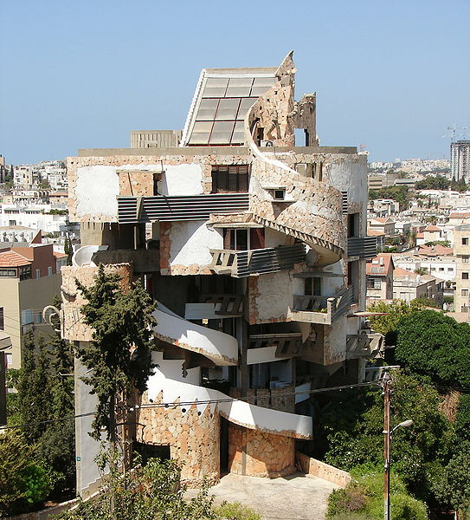  SpiralHouse | 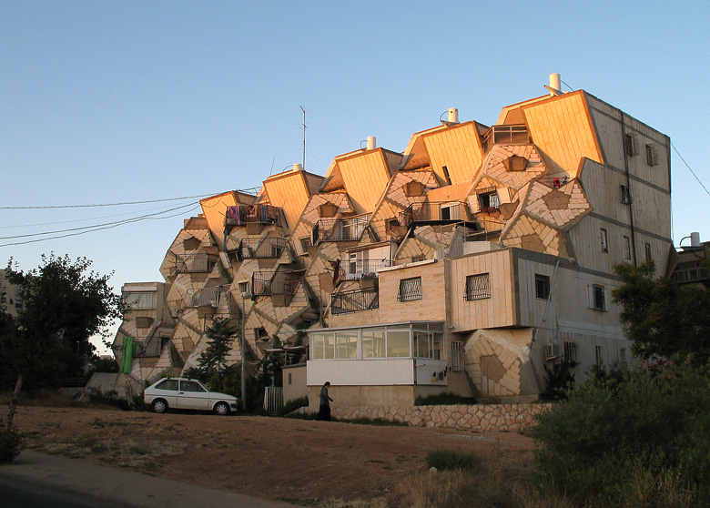  Ramot polin
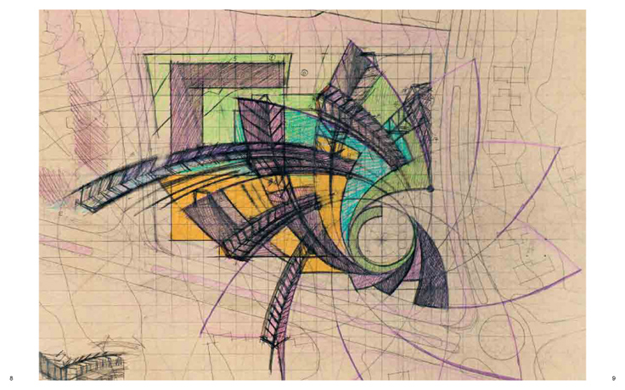 | 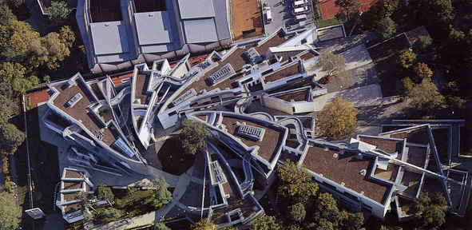
Heinz Galinski School, Berlin, 1995, Zvi Hecker

